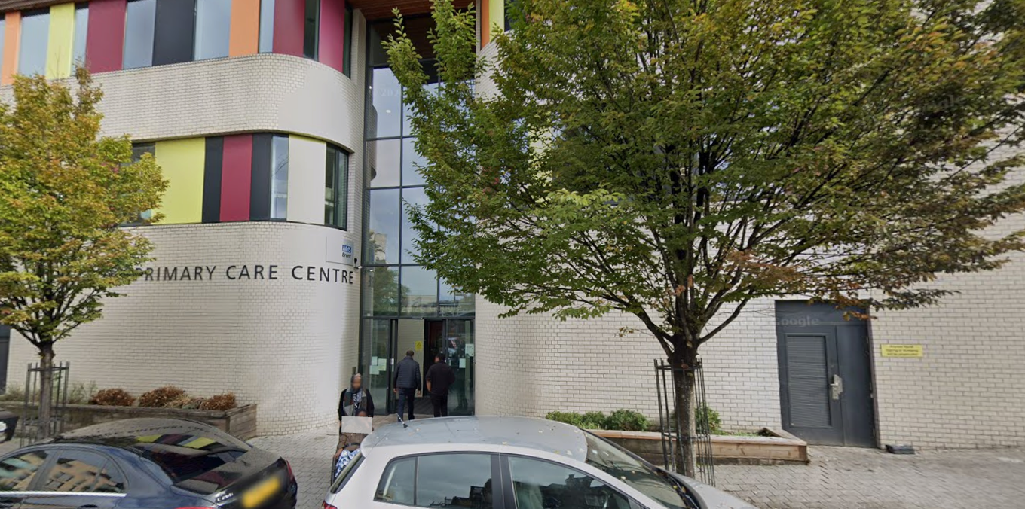

Enter and View
STONEBRIDGE PRACTICE
DECEMBER 2025
Contents

Overview | 3
Methodology | 4
Findings – Key themes | 4 - 7
Complaint system / access to service | 6 - 7
Social prescribing |  | 7 - 8
Recommendations and conclusion |  | 8
Response from Practice Manager |  | 9

Overview

From December 2021 to March 2022, Healthwatch Brent undertook a public engagement project to understand the experience of arranging a General Practice (GP) appointment across Brent. In Winter 2025, Healthwatch Brent decided to follow up on how the situation has progressed by undertaking a more in-depth piece of work to ensure improvements and the voices of residents are heard. The complaint system across Brent varies considerably in terms of standards. Healthwatch Brent undertook Enter and View visits to selected GP surgeries to find out if any improvements in services had been made. We examined whether the complaints system was more accessible and evaluated how GP practices varied. This GP practice is in Stonebridge, a particularly diverse ward nested in a diverse borough. Of note, 79% of Stonebridge residents are Black, Asian & minority ethnic groups, with 26% of residents using a main language other than English, and 15% of residents are disabled.

Visit details

Name of the GP Practice | Stonebridge Practice, Hillside Primary Care Centre, 150  Hilltop Avenue, NW10 8RY
Practice Manager | Susan Okaikoi
Date of visit | December 2025
Authorized Representatives: | Ibrahim Ali, Mary Evans

What is Enter & View

Part of the local Healthwatch programme is to carry out Enter and View visits. Local Healthwatch representatives and trained resident volunteers, carry out these visits and make recommendations where there are areas for improvement/ areas of best practice that can be shared.
The Health and Social Care Act allows local Healthwatch authorised representatives to observe service delivery and talk to service users, their families, and carers on premises such as hospitals, residential homes, GP practices, dental surgeries, optometrists, and pharmacies. Enter and View visits can happen if people tell us there is a problem with a service, but, equally, they can occur when services have a good reputation – so we can learn about and share examples of what they do well from the perspective of people who experience the service first-hand.
Healthwatch Enter and Views are not intended to identify safeguarding issues specifically. However, if safeguarding concerns arise during a visit, they are reported in accordance with Healthwatch safeguarding policies. If at any time an authorised representative observes anything that they feel uncomfortable about, they need to inform their lead, who will inform the service manager, ending the visit.
In addition, if any staff member wishes to raise a safeguarding issue about their employer, they will be directed to the Care Quality Commission, where they are protected by legislation if they raise a concern.

Methodology

The Covid pandemic fundamentally changed the way GP surgeries operated. The move to online consultations and phone bookings made remote access the ‘new normal’. Some residents struggled to keep up with these changes due to lack of access to the internet, computer equipment, or training. GP surgeries were revisited to check if any significant changes or adaptations have been made and what barriers to raising complaints exist.
The process of complaining about GP services can be very confusing for the public. In many instances, GPs employ their own staff, and each surgery has to have a procedure for all complaints - with a specific person being allocated to take responsibility for dealing with the complaint.
In 2024, written complaints in the NHS reached a record high. The Healthwatch England report ‘A Pain to Complain - Why it’s Time to Fix the NHS Complaints Process’ (2025) outlines that more than half (56%) of people who experienced poor NHS care in the past year took no action, and fewer than one in ten (9%) made a formal complaint.
The National Director for Primary Care and Community Services, NHS England, Amanda Doyle, highlighted that GP teams are already delivering over 1.4 million appointments every working day and that “there was need to upgraded thousands of practice phone systems and introduced online request forms, making it easier for people to contact their surgery in a way that suits them, while keeping phone lines free for those who need urgent care.”

Findings: key themes:

Building & Environment

The building was modern, clean, with a central location. Parking space was available at the rear of the building. Internal toilets were available for use by patients. An elevator was available which could be used by wheelchair or disabled patients. The sign posting at the entrance was poor and the name of the practice was not at the entrance. As one approached the building, the signage was not at eye level and was very high. No leaflets were on display, but there was an electronic screen with health information. There were no children’s toys or books in the waiting area. There was a prominent noticeboard in the waiting area. A hearing loop was available at the front desk.
Both staff and patients were questioned about their experience of the services provided at the GP Practice.
Staffing Levels

The staffing levels are as follows:-

- Number of GPs: 2
- Number of Health Assistants: 4
- Number of other staff: 12
There were two receptionists on duty. One receptionist was bilingual and was able to converse with patients who had Somali as a first language. The receptionists were friendly and had excellent communication skills. Receptionists called out the name of the patient. The Healthwatch Brent representatives observed calm and friendly staff at reception. Somali language service was available at reception for those residents who were not fluent in English.

Feedback from Staff

Staff were interviewed by the Healthwatch Brent authorized representatives. An effort was made to delve deeply into the mechanism and approach of staff to management of complaints. The feedback indicated that staff actively listen to complaints. Patients are informed of the complaints procedure so that that there is clarity. First steps taken are to try to resolve the issue. If the patient still wants to proceed with the complaint, they are given a form to fill in at reception. Staff believed that they received adequate training and support. Missed appointments impacted the number of appointments the surgery could offer. Staff expressed that they had enough time to appropriately manage their workload. Staff also mentioned that they had an excellent team and a very supportive practice manager. Staff expressed that more patients learning to utilize the NHS App would help them gain awareness of all the services available to them.

Appointments
Patients were asked if it was easier or more difficult to make an appointment.

Access to appointments | Easy | Same | More difficult
Access to appointments | 4 | 6 | 2

Access to GP of choice? | Yes | No
Access to GP of choice? | 2 | 10

Waiting time to be seen by doctor? | Less than 15 minutes | Up to 30 minutes | More than 30 minutes
Waiting time to be seen by doctor? | 12 | 0 | 0

Making appointments online? | Easy | Difficult | Neither | Needed help from another person
Making appointments online? | 4 | 3 | 2 | 3

Patient Evaluation of Services

Are staff polite and approachable? | Yes | No | Sometimes
Are staff polite and approachable? | 12 | 0 | 0

Complaint System and Access to Services

The Stonebridge Practice has a flexible approach to accessing services. Bookings and enquiries by phone, in-person, and online are available. The complaint system involves a clear process. There is a no tolerance of abuse policy. The first option in dealing with anti-social behavior is to try and de-escalate the situation. A letter is also sent out, while making every effort to de-escalate the situation. Initially the patient is given a warning. The practice allows the patient to have a maximum of 3 warnings before any other action is taken. Every effort is made to calm the patient and reduce any tension. Staff stated that patient-patient aggression is not tolerated, and safety of staff is also taken into consideration. If there is tension between a patient and the GP, sometimes it is possible to provide an alternative GP for the patient so as to diffuse any tension. The emphasis is on conflict resolution, and this works well in reducing the level of incidents. The Practice Manager is very approachable and flexible, which helps defuse such situations.
The surgery offers social prescribing services and works closely with local partners such as Brent Health Matters and Brent Mencap. This allows them to reach vulnerable patients, such as people with learning disabilities, mental health issues, elderly and people with low literacy skills. They have an option of either digital or printed material. The literacy rates across the different boroughs of Brent vary considerably. According to the 2021 Census, Brent has the highest proportion of adults in London with no formal qualifications. Below is an estimate based on the Census 2021 of the ranking of wards with % residents with no qualifications (ranking lowest first):
- Stonebridge
- Tokyngton
- Harlesden
- Kensal Green
- Wembley
From the data it can be observed that the ward of Stonebridge has a high number of residents who do not have any qualifications. Stonebridge consistently ranks high for no qualifications and has a very high level of economic inactivity. In some parts of Stonebridge, the level can be as high as 35%. This might impact patients’ ability to access online services; However, Stonebridge Practice offers training on how to use Patches and still offers a walk-in service to talk to receptionists and get help with booking appointments. Patients are also able to contact the practice via phone. Healthwatch Brent staff observed staff taking phone enquiries. Receptionists offered patients additional help through social prescribing. They were observed to be helpful, calm, and informative. Patients were given the choice of face-to-face appointment or online appointments. As previously observed, patients express the desire to have more time with the GP. There were considerably fewer complaints about using online booking compared to the previous visit conducted by Healthwatch Brent. This suggests that the Stonebridge Practice has been successful in helping residents gain skills in using online booking. All patients stated that staff were polite.
Social Prescribing

Social prescribing is a holistic approach often termed "community referral," that empowers health professionals to connect patients to non-clinical, community-based services to address social, economic, and environmental factors affecting their health. It focuses on addressing issues like loneliness, debt, or poor housing through personalized support. According to NHS England, referrals are primarily initiated by GPs or primary care professionals to address needs that clinical care alone cannot.
Social Prescribing Link Workers provide confidential, non-judgmental, and practical support to help residents identify goals, such as accessing social groups, financial advice, or wellness activities. Support often includes addressing mental well-being, reducing isolation, and improving quality of life. The Stonebridge Practice works in partnership with Brent Mencap and Brent Health Matters (BHM) to make sure that patients are consistently offered the support of social prescribing link workers. Social prescribing is a useful tool in addressing health inequalities, especially for residents who live in areas of high deprivation who are more likely to have worse health outcomes due to socio-economic factors. The practice has 3 link workers; the Primary Care Network (PCN) has 8 in total. They work closely with Mencap in the delivery services. Social prescribing is a success story at Stonebridge Practice. The practice works closely with BHM to support patients. The practice receives feedback from BHM on the outcome of referrals. The reception team signposts patience to DWP and other services. The partnership work with Mencap and BHM works well and provides a good social prescribing service. Patients with mental health problems are sign-posted to the Brent Cove drop-in. The quality of service offered to patients with regards to accessing support from social prescribing is excellent. The practice still offers home visits and is passionate about providing access to services for home-bound patients.

Recommendations

The service provided by the Practice was excellent and we do not have any significant recommendations for improvement.
- The sign posting at the entrance was poor and the name of the practice was not at the entrance. As one approached the building, the signage was not at eye level and was very high.
- Display up-to-date leaflets (including diverse languages used in the community) so as to give patients more choices and knowledge as to what is available locally. These could be displayed on the noticeboard.

Conclusion

Patients were proactively offered social prescribing service. The receptionist frequently explained to patients what was available. The policy for dealing with complaints and anti-social behaviour is flexible.
The strong provision of social prescribing and highly trained staff helps patients feel heard. The Stonebridge Practice, Mencap, and BHM work very well together, and patients are signposted to a variety of services. The practice has three link workers, and the team provides a high-quality service.
The social prescribing provided by Dr Subash and the team gives a good example of how social prescribing can work well when effective partnerships are in place. Staff help anyone struggling with using online booking system. A specific time in the daily schedule is set aside exclusively for helping anyone needing help with using Patches. All these factors mentioned help reduce any tension that might arise, since patients are proactively listened to and sign-posted to other services.

Response from Practice

Please see attached pictures from the façade of the building, signage at the entrance on the lower ground floor, signage at the bottom of the stairs on the lower ground floor and signage at the top of the stairs. Kindly review and provide me some suggestions for change, in order for me to share your recommendations with the Estates.
Kindly see pictures of leaflets outside consultation rooms.
Infection control advise is for all toys and books to be removed from waiting area.
All on line appointments ask patients to state GP of choice.
Kindly see attached picture. Leaflets are available outside all clinical rooms.
(Pictures provided)

