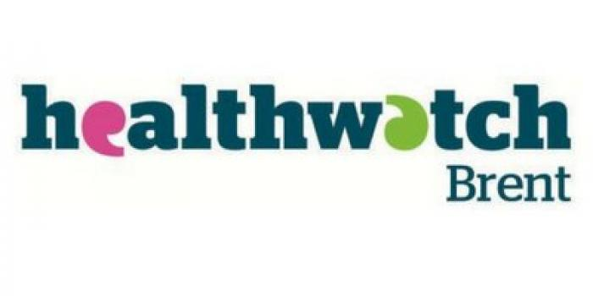

Healthwatch Brent
Governance and Prioritisation Process
May 2021

Document control

Version | 1.0
Author | Steve Inett
Approved by | The Advocacy Project Board of Trustees
Date approved | 20 May 2021
Effective date | 20 May 2021
Review date | 20 May 2022

Policy statement
Healthwatch Brent makes its decisions in an open and transparent way and ensures the interests of the people of Brent are always put first. This process outlines the steps taken to ensure priorities are evidence based and lead to substantive impact in the community.
The governing regulations and standards are:
- The NHS Bodies and Local Authorities (Partnership Arrangements, Care Trusts, Public Health and Local Healthwatch) Regulations 2012 – referred to as Regulation 40 throughout this document.
- Freedom of Information Act 2000.
- Seven Principles of Public Life (Nolan Principles).
This policy applies to all relevant decisions made by Healthwatch Brent.

Relevant decisions
Regulation 40 requires Healthwatch Brent to have in place and publish procedures for making relevant decisions. Relevant decisions include:
- How to undertake our activities.
- Which health and care services we are looking at covering with our activities.
- The resources we will use on our activities.
- Whether to request information.
- Whether to make a report or a recommendation.
- Which premises to Enter and View and when those premises are to be visited.
- Whether to refer a matter to Overview and Scrutiny Committee.
- Whether to report a matter concerning our activities to another person.
- Any decisions about sub-contracting.
Relevant decisions do not include day-to-day activity that may be required to carry out exploratory work prior to making a relevant decision.

1 Responsibility for priority setting

Healthwatch Brent Governance model

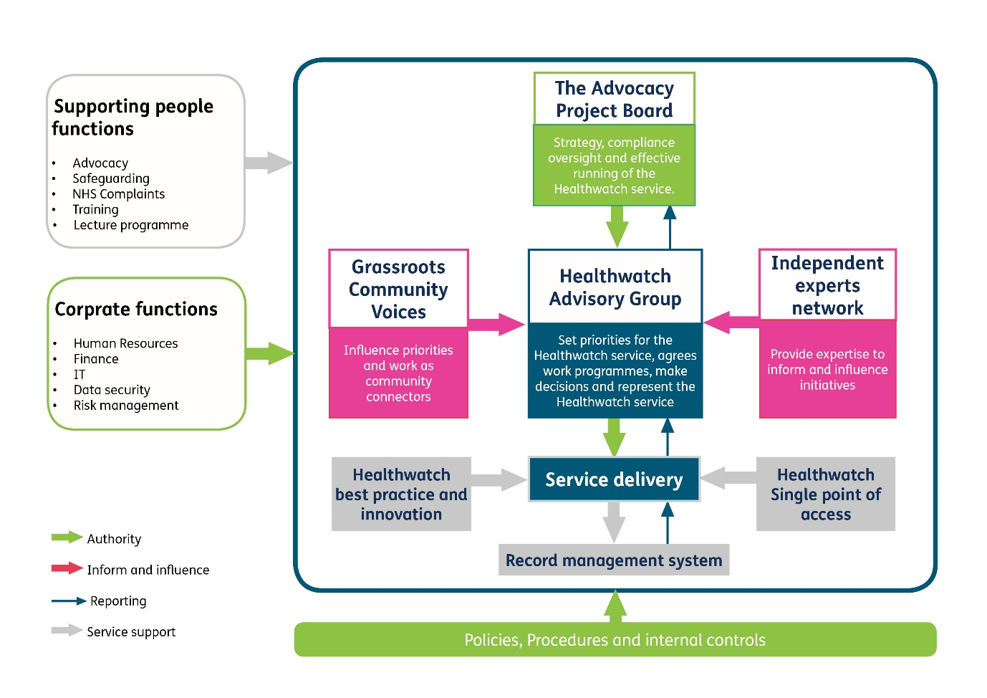

The Advocacy Project Board of Trustees

The Advocacy Project is the organisation that holds the contract for Healthwatch Brent. It is the employer of staff working within Healthwatch Brent. It delegates the line management of the Healthwatch Manager to the CEO (who is also a trustee as this is a unitary board) and delegates priority setting to the Healthwatch Brent Advisory Group.
The Advocacy Project Board of Trustees must be assured that the governance structure and processes in place to deliver Healthwatch Brent are robust and that the service meets its contractual and statutory obligations. It should also ensure the highest standards of quality and adherence to best practice, in particular the Healthwatch Quality Framework.
The Advocacy Project Board will periodically review the decisions, initiatives and activity taken by Healthwatch Brent to continue to assure itself that the governance structures and bodies are fit for purpose. It will do this through reporting from the Manager via the CEO, as well as having a representative on the Advisory Group.

Healthwatch Brent Advisory Group

Aims of the group:
- To ensure there is collective responsibility in setting the priorities and strategic direction of the organisation as set out in the Healthwatch Brent Workplan and Strategy.
- To ensure the views of the Brent Grassroots Community Voices are heard in the prioritisation process.
- To ensure the views of the Independent Experts Network are heard in the prioritisation process.

Objectives:
- Work in constructive partnership with the members of The Advocacy Project Board, Brent Grassroots Community Voices, Independent Experts Network, staff and volunteers
- To have active oversight of the process for setting annual priorities for the organisation
- Regularly review the list of priorities, receive updates on potential new more urgent priorities and advise how the list of priorities should be adjusted.
- Monitor the progress of project work and other activity on priorities, hold staff and volunteers to account if they are not progressing things effectively and that stakeholders are aware of any significant delays in project timeframes.
- Identify what difference a Healthwatch intervention has made and take a view on whether it is enough.
- Advise on utilising Enter & View effectively
- Evaluate whether we are effectively balancing how we raise the voices of the public and challenge services to improve, with ensuring we work in a professional, collegiate, constructive manner with stakeholders.
- Consider whether Healthwatch Brent is suitably visible to public and stakeholders.

Membership:
- 1 trustee from The Advocacy Project Board (Chair of the Advisory Group)
- 2 representatives of the Brent Grassroots Community Voices
- 2 representatives from the Independent Experts Network (different people will be invited to attend as representatives of the network as required by the agenda).
- 4 members of the public
- 2 Healthwatch Brent volunteers
- Healthwatch Manager
The Advisory Group determines which aspects of health and social care will be looked at as a priority each year. It must remain independent of any undue influence and be free to select the priorities it feels represent the best for the residents of Brent. Transparency, rigour, and objectivity are the basis for the Advisory Group’s effective and successful working.
There are two mechanisms for them to set the priorities of Healthwatch Brent:
- Annual priority setting
- Regular review of the workplan and recommendations of new priorities throughout the year

Annual Priority Setting
The Healthwatch Brent Workplan of priorities is set by April each year. Potential priorities can come from a number of sources:
- What Healthwatch Brent has heard from the public
Healthwatch Brent records issues throughout the year that could be potential priorities (see the section on Regular Review).
- Health commissioning plans
Clinical Commissioning Groups are required to produce an annual commissioning plan. Strategic meeting such as governing body meetings, Health and Wellbeing Board and Health Overview and Scrutiny Committee give further intelligence on strategic issues.
- Social care commissioning plans
Social care commissioners plan forward decisions that impact on commissioning. Meetings of the council cabinet and social care committee provide further intelligence.
- Intelligence from the Brent Grassroots Community Voices and other community and voluntary stakeholders
The Grassroots Community Voices shares local experiences and issues of concern and provides links with local voluntary sector infrastructure and charities delivering health and social care services.
- Intelligence from other projects delivered by The Advocacy Project
The experiences of people gathered via the advocacy, personal health budget and user involvement work that The Advocacy Project also deliver are a rich source of issues for Healthwatch Brent to investigate further.
- Joint working proposals from neighbouring Healthwatch and Healthwatch England
Neighbouring boroughs will be undertaking work that either impacts on Brent residents or residents can contribute to. Healthwatch Brent works closely with its neighbours but needs to ensure it has capacity before it commits to any joint working. This also applies to Healthwatch England campaigns.
Some of these priorities involve ongoing involvement in meetings and monitoring the progress of agreed areas, some will mean doing additional work to understand the service and the experiences of the public. Healthwatch Brent gathers as much information as possible on the aims of each potential priority, any known timescales and an understanding of what form the work might take.
The paid team compiles the information on any potential priority which it shares with the Advisory Group to ensure they have all available information to make a decision.
The Advisory Group receives the information and agrees which ongoing and monitoring priorities will be included in the workplan.
The Group will have the power to delegate some of the relevant decision making to the Lead Officer of Healthwatch Brent, for example, small pieces of work which do not have a substantive impact on staff or financial resources.
For priorities requiring additional work which requires a project approach, the Advisory Group ensures Healthwatch Brent only agrees to projects they have the capacity to deliver. They select based on:
- potential for most impact and change
- what can be realistically resourced?
- ensuring seldom heard groups are represented.
This process uses the Healthwatch England Research project Planner Questions to interrogate each proposal fully:

Project objectives – What the is project seeking to achieve
Criteria Action Date
Does this fit with our strategic objectives and statutory remit?
What is the evidence base for this work?
What is the proposed impact on individuals and the community?
Can we influence change, or is there an organisation better placed to do so who we can work with or approach?

How will we undertake our activities?
Which services will we cover?
What additional information will we need to request and who from?
Is an Enter and View required? What premises will be included? What is the timescale?

Resource requirements (people and financial)
Does this fit with our overall work plan? Do we have the staff and volunteers to deliver?
How much will we spend? Are there additional funding requirements to deliver this project?

Project deliverables – What difference or impact will the project have?
What will be the outcome of our work? How will we demonstrate impact? A report? Recommendations?

Communication – Who will be interested in our outcomes and impact?
Does this need to be referred to the local Overview and Scrutiny Committee?
Who will we share our planned work and our findings with?
Do we need to subcontract?

This list becomes the workplan and is then shared with the public and stakeholders. These decisions and any others, including those delegated to the Manager, are recorded in the minutes. Once a decision has been made, the staff team is responsible for implementation and delivery, with an agreed reporting process to Group.
The dates and details of how the public can observe each Advisory Group meeting and the minutes of each meeting are published on the Healthwatch Brent website.

2 Regular Review
Healthwatch Brent is continuously ‘horizon scanning’ for issues that were unforeseen and may become urgent. The Advisory Group meets bimonthly and reviews new information and intelligence. It then reviews the Healthwatch Brent Workplan and determines whether new work should be added to the workplan, replace an existing workplan priority, or be rejected as a priority due to insufficient resource.
The Advisory Group also receives updates on the progress of projects and activities and information about levels of resources so that they can weigh the capacity of the organisation.
The group operates by discussion and consensus and is attended by the trustee representative from The Advocacy Project Board, who has the authority to escalate to the Board any activities that they consider to be contrary to the contract performance framework, the statutory duties or best practice.
The Advisory Group is empowered to take agreed actions forward within the allocated budget and available resources and determine delivery timeframes.

3 Outcomes
Healthwatch Brent follow up all recommendations they make through projects with the relevant organisations. For larger projects there is an outcome review at six and/or twelve months after the project report is published. These outcomes are monitored in the Impact Tracker recommended by Healthwatch England and published in a regular impact report. Where there is resultant service change this is recorded in You Said We Did and published.
The Advisory Group receives these documents, so they can review the effectiveness of Healthwatch Brent in carrying out its aims and having sufficient impact.

4 Dealing with Breaches of this Process
If a decision is taken in the name of Healthwatch Brent without authorisation in the manner set out in this process document, The Advocacy Project Board will determine what action is needed. This may be to either approve the decision retrospectively, or to reverse the decision.
If the breach of the agreed procedure is considered to have also breached the contract between Healthwatch Brent and Brent Local Authority, it will be reported to the Local Authority and further action agreed between the Local Authority and Healthwatch Brent.
In each eventuality, actions will be minuted and published on Healthwatch Brent’s website.

5 Review of This Process
This process will be reviewed annually by The Advocacy Project Board. Additionally, it will be reviewed in response to a breach or any feedback that indicates a more urgent need for review. Any amendments to this policy and the procedures governing the making of relevant decisions will require a simple majority of board members voting in favour.
The amended policy document will be published on the website of Healthwatch Brent as soon as is practicable.

6 Equality, Diversity, and Inclusion statement
Healthwatch Brent is committed to ensuring all decisions made are free from any form of discrimination on the grounds of age, disability, gender, gender reassignment, marriage and civil partnership, pregnancy and maternity, race, religion or belief, sex and sexual orientation, in accordance with the Equality Act 2010.
Healthwatch Brent will monitor this policy to identify whether it is having an adverse impact on any group of individuals and act accordingly.

