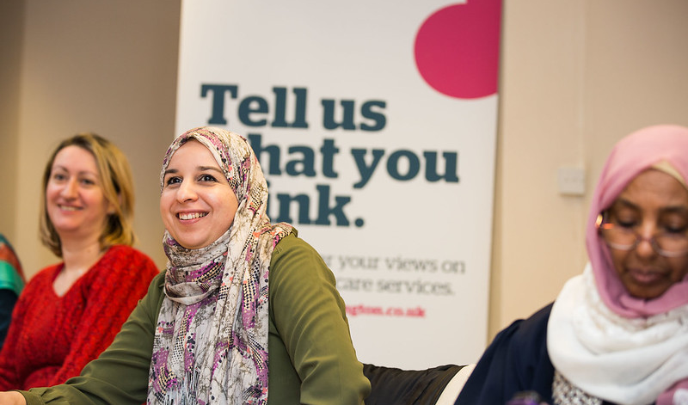
Healthwatch Brent
Community Researcher Pack
About Healthwatch Brent

Healthwatch Brent is one of 152 local Healthwatch organisations set up across England since 2013.

Its primary aim is to improve health and social care services for local people. Healthwatch champions the rights of people who use health and social care services, and holds services to account for how well they engage with the public. Healthwatch supports patients, service users, carers and the public to be actively involved in how services are commissioned and delivered.

The Advocacy Project are the contract holders for Healthwatch Brent. In accordance with the contractual requirements between Healthwatch Brent and its commissioning body, Brent Borough Council, and the legal status of The Advocacy Project, the accountability for delivery and final decision-making are undertaken by the Healthwatch Brent staff, the Chief Executive and Healthwatch Brent Advisory Group.

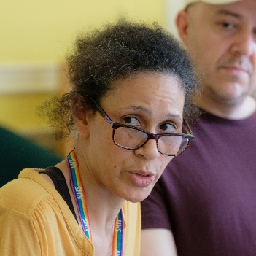
When people who use services are involved in this way, services improve and the people involved gain confidence and skills.
Staff survey

Why become a community researcher?

Healthwatch Brent are wanting to work with people from Eastern European communities to help us engage and listen to the experiences of Eastern European people living in Brent when accessing health and social care services.
Being a community researcher with Healthwatch Brent gives you the chance to:
- Make a difference to your local community by helping them to have a say about local health and social care services
- Build your skills and knowledge within a friendly, supportive team
- Be trained by Healthwatch experts
- Gain experience for your CV
- Meet new people

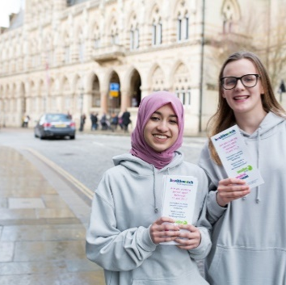

Who are we looking for?
Community Researcher roles are open to anyone who lives in Brent and is from the Polish or Romanian communities, with a passion for improving health and social care. If you want to support us to understand the experiences of people from your community to help service providers understand what the barriers and blocks are when accessing health and social care services in Brent, we would be delighted to hear from you.
All Community Researchers will receive:
- An induction into Healthwatch Brent
- Ongoing training and support
- Payment for time at London Living Wage
You will be asked to:
- Sign a Healthwatch Brent Agreement
- Agree to have a full DBS check to carry out engagement work
- Complete training
- Commit to 5 hours a week for 6 months
Community Researcher Role Description
About the role:

Engaging with local people and building relationships with their communities is at the heart of Healthwatch Brent’s approach to improving health and social care services. We want to reach the most disadvantaged and seldom heard groups, to make sure their voices are heard. To help us do this, we are recruiting two Community Researchers for our outreach and engagement activities with Eastern European communities.

Key responsibilities

- To work with Healthwatch Brent Communications and Engagement Officer by engaging with local people and communities from Eastern European groups
- To gather views about health and social care services in Brent from local Eastern European people and community groups
- To accurately report the views you gather to Healthwatch Brent
- To feedback information from Healthwatch Brent to people and groups in a way that is easily understood
- To investigate issues of particular concern through discussions with local people and community groups under the guidance of the Communications and Engagement Officer
- To attend local events and meetings
- To maintain an active interest the work and activities of Healthwatch Brent
- To undertake ongoing training as required
- To commit to the time required to fulfil the role
- To inform the Healthwatch Brent office in a timely fashion if you cannot keep to a commitment required by the role

What we look for in Community Researchers

- Good local knowledge
- The ability to connect with a wide range of individuals and community groups, and to support them in voicing their opinions
- The ability to present information to different audiences
- The ability to separate your experiences from other people’s issues and to present the views of those you represent without bias
- Willingness to ask for support and to accept guidance
- Polish or Romanian language skills in addition to English are essential
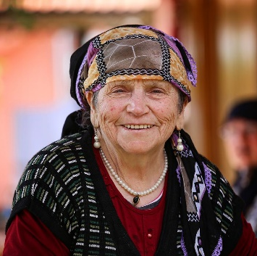
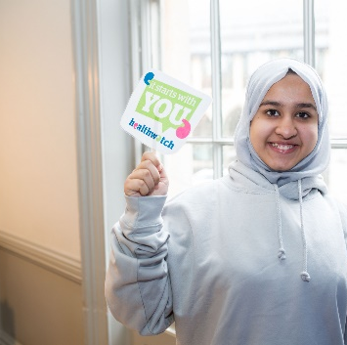
Your attitude and values. You should be:

- Committed to helping people have a voice
- Non-judgemental
- Committed to the practical application of equal opportunities
- Reliable and trustworthy
- Respectful, supportive and empathetic when dealing with others
- Motivated to learn and develop new skills

Closing date 27 June
To apply for the role, please fill in the application form
and send this to us no later than 27 June
email: info@healthwatchbrent.co.uk
Application Form
Name: | Date:
Address:

Contact Number:
Email:
We will contact you via e-mail unless you notify us otherwise.
Please tick the box if you wish to receive correspondence by post
Why are you interested in being a Community Researcher?

Please tell us about the personal qualities you can bring to the role?

What is your availability? (e.g. Time/Days/Evenings/Weekends)

Please explain why you think you are suitable for this role. Please tell us about any experience you have that you consider relevant to the role. (Continue on a separate sheet if required)

If called for an informal interview, do you require any reasonable adjustments to be made? Please give details below, continuing on a separate sheet if required.

Please provide the contact details for two people who can act as a reference for you:
Name  Address  Tel  Email | Name  Address  Tel  Email
The information I have supplied is a true and accurate account of my experience and suitability to perform this role.
Signed: |  | Date:

Please return this form by email to info@healthwatchbrent.co.uk

EQUAL OPPORTUNITIES - MONITORING FORM
The information on this form is collected so that we can assess the effectiveness of our equality policy and monitor our recruitment processes. We aim to be representative of the community in which we work and by monitoring the diversity of our applicants, we can assess our effectiveness in achieving this goal.
The information you give will only be used for this purpose and no other. This form will be detached from your application before we look at your application and is entirely anonymous .
Please read through each section with care before completing it. If you do not want to answer any specific question, please leave it blank.

PERSONAL DETAILS
- Age
Under 18 18 – 24 25 – 34 35 – 44 45 – 54 55-64
65-75 75+

- Gender
Male Female Prefer not to say Prefer to self-identify........................
- Disability
Do you consider yourself to have a disability? Yes No
If you have answered yes, please give details of your disability below:
.....................................................................................................................
- Sexual orientation
Bisexual Gay man Lesbian/gay woman Heterosexual/Straight
Prefer to self-identify.................................
- Ethnic Origin
White

☐ English/Welsh/Scottish/Northern Irish
☐ Gypsy or Irish Traveller
☐ Irish
☐ White other

Asian/Asian British
☐ Chinese
☐ Bangladeshi
☐ Indian
☐ Pakistani

Black, African, Caribbean, Black British
☐ African
☐ Caribbean

Multiple Ethnic Group
☐ White and Black Caribbean
☐ White and Black African
☐ White and Asian

Other Ethnic Group:
☐ Arab
☐ Prefer not to say

Prefer to self-describe ………………………….

- Faith/Religion/Belief
☐ Buddhist ☐ Christian ☐ Hindu ☐ Jewish ☐ Muslim ☐ Sikh
☐ Prefer not to say Prefer to self-describe ………………………….

- Are you a carer?
☐ Yes ☐ No ☐ Prefer not to say
__________________________________________________________________

What is the first part of your postcode? (i.e. NW9)
How did you find out about this role?
Healthwatch Brent newsletter or flyer
Healthwatch Brent website
Through another voluntary/community organisation
Other (please state) ........................................

